**Name: Anish Ashok Sharma Sap id: 60003220045**

**Branch: Information Technology Div: D/IT1**

**Course**: **Object Oriented Programming using Java**

# Experiment no. 5

Aim: To implement class with members and methods (static, non-static, recursive and overloaded methods)

**Problem Statement 1:**

WAP to find value of y using recursive function, where y=x^n

Code:

import java.util.*;

class Power

{

public static int recursion(int b,int pow)

{

if(pow==0)

return 1;

else{

return b*recursion(b,pow-1);

}

}

public static void main(String args[])

{

Scanner obj=new Scanner(System.in);

System.out.println("Enter base and power:");

int base=obj.nextInt();

int pow=obj.nextInt();

int ans=recursion(base,pow);

System.out.println("Power:"+ans);

}

}

Output

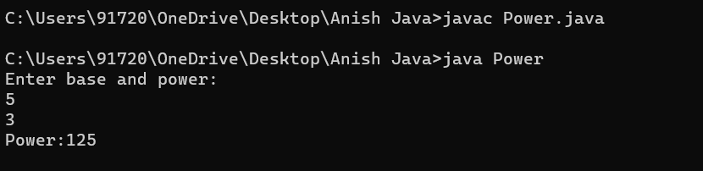

**Problem Statement 2:**

WAP to display area of square and rectangle using the concept of overloaded functions.

Code:

import java.util.*;

class Area

{

int rectArea(int x,int y)

{

return x*y;

}

double rectArea(double x,double y)

{

return x*y;

}

double sqaArea(double x)

{

return x*x;

}

int sqaArea(int x)

{

return x*x;

}

}

public class AreaRS

{

public static void main(String[] args)

{

Scanner obj=new Scanner(System.in);

int area1,area2;

Area obj1=new Area();

System.out.println("Enter length and width");

int len=obj.nextInt();

int wid=obj.nextInt();

area1=obj1.rectArea(len,wid);

System.out.println("Enter side of sqaure");

int side=obj.nextInt();

area2=obj1.sqaArea(side);

System.out.println("Area of rectangle is"+area1+" and Square is "+area2);

}

}

Output

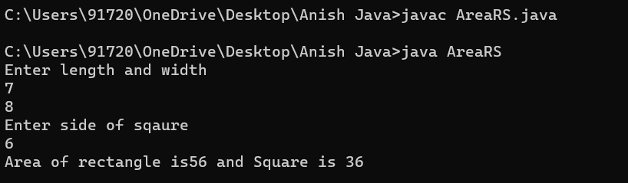

**Problem Statement 3:**

WAP to perform mathematical operations on 2 complex numbers by passing and returning object as argument.

Code :

import java.util.*;

public class Complex {

double real;

double imag;

public Complex(double real, double imag) {

this.real = real;

this.imag = imag;

}

public static void main(String[] args) {

Scanner obj=new Scanner(System.in);

System.out.println("Enter real and imag part:");

double r1=obj.nextDouble();

double i1=obj.nextDouble();

Complex n1 = new Complex(r1, i1);

System.out.println("Enter real and imag part:");

double r2=obj.nextDouble();

double i2=obj.nextDouble();

Complex n2 = new Complex(r2, i2);

Complex temp;

temp = add(n1, n2);

System.out.printf("Sum = %.1f + %.1fi", temp.real, temp.imag);

}

public static Complex add(Complex n1, Complex n2)

{

Complex temp = new Complex(0.0, 0.0);

temp.real = n1.real + n2.real;

temp.imag = n1.imag + n2.imag;

return temp;

}

}

Output

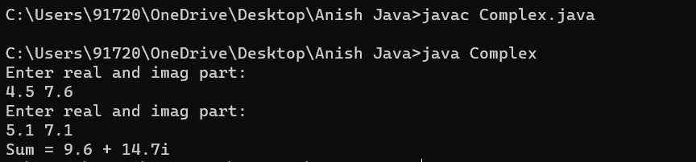

**Problem Statement 4:**

WAP to count the number of objects made of a particular class using static variable and static method to display the same.

Code:

public class ObjectCount1

{

static int count=0;

public static void count()

{

count++;

}

public static void main(String args[])

{

ObjectCount1 c1=new ObjectCount1();

c1.count();

ObjectCount1 c2=new ObjectCount1();

c2.count();

ObjectCount1 c3=new ObjectCount1();

c3.count();

System.out.println("Total Number of Objects: "+count);

}

}

Output

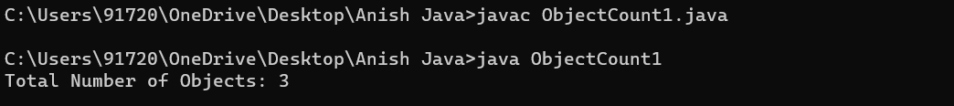

**Problem Statement 5:**

WOOP to arrange the names of students in descending order of their total marks, input data consists of students details such as names, ID.no, marks of maths, physics, chemistry. (Use array of objects)

Code :  
class StudentMarks

{

String name;

int id;

int math,phy,chem;

int total;

}

class Stud

{

public static void main(String[] args)

{

StudentMarks s1=new StudentMarks();

s1.name="Anish";

s1.id=45;

s1.math=99;

s1.phy=97;

s1.chem=96;

s1.total=s1.math+s1.phy+s1.chem;

StudentMarks s2=new StudentMarks();

s2.name="Manish";

s2.id=78;

s2.math=99;

s2.phy=95;

s2.chem=88;

s2.total=s2.math+s2.phy+s2.chem;

StudentMarks s3=new StudentMarks();

s3.name="Sonali";

s3.id=34;

s3.math=97;

s3.phy=95;

s3.chem=85;

s3.total=s3.math+s3.phy+s3.chem;

StudentMarks array[]=new StudentMarks[3];

array[0]=s1;

array[1]=s2;

array[2]=s3;

System.out.println("Name id total ");

System.out.println(array[0].name+" "+array[0].id+" "+array[0].total);

System.out.println(array[1].name+" "+array[1].id+" "+array[1].total);

System.out.println(array[2].name+" "+array[2].id+" "+array[2].total);

}

}

Output

